**Operational Efficiency Analysis - Manufacturing Sector**

GOKULNATH K & E24755

**Overview**

Operational efficiency analysis in manufacturing focuses on optimizing production processes to minimize waste and maximize output. Key metrics include cycle time, overall equipment effectiveness (OEE), and resource utilization. Data analysis helps identify bottlenecks, reduce downtime, and improve workflow by leveraging techniques like process mapping, predictive analytics, and real-time monitoring. Insights from this analysis lead to enhanced productivity, cost reduction, and streamlined operations.

**Objective**

1. **Maximizing Production Output:** Optimize production processes to increase throughput while maintaining product quality.
2. **Reducing Cycle Time:** Minimize the time taken to complete production cycles, reducing delays and improving delivery speed.
3. **Enhancing Resource Utilization:** Ensure efficient use of materials, labor, and equipment to reduce waste and operational costs.
4. **Improving Overall Equipment Effectiveness (OEE):** Increase equipment performance by minimizing downtime, speed losses, and defects.
5. **Identifying Bottlenecks:** Detect and address constraints or inefficiencies in the production line to streamline workflows.
6. **Reducing Operational Costs:** Leverage data to cut down energy usage, material wastage, and labor inefficiencies.
7. **Improving Predictive Maintenance:** Use historical data and real-time monitoring to predict equipment failures, minimizing downtime and repair costs.
8. **Enhancing Decision-Making:** Provide actionable insights through data-driven models for continuous process improvement.
9. **Ensuring Sustainability:** Reduce environmental impact by improving resource efficiency and cutting waste.

**Assigned Task(s)**

* Operational Efficiency Analysis - Manufacturing Sector

**Task Details**

* **Task 25 :** Operational efficiency analysis in manufacturing uses data analytics to optimize production processes, reduce waste, and improve output. It focuses on metrics like cycle time, resource utilization, and equipment effectiveness for cost reduction and productivity enhancement.
* **Status:** Completed.
* **Details:**

**1. Dataset Analyzed:** Analyzed dataset with key fields such as workstation ID, product type, cycle time, downtime, units produced, defective units, shift, and date.

**2.** **Null Value Check:** Identified null values in the dataset for each column to ensure data completeness.

**3.** **Basic Data Overview:** Loaded and displayed an initial summary of the dataset.

**4. OEE Calculation:** Calculated Overall Equipment Effectiveness (OEE) by considering good units, defective units, cycle time, and downtime.

**5.** **Resource Utilization:** Calculated resource utilization as the ratio of good units produced to cycle time.

**6.** **Cycle Time Distribution:** Visualized the distribution of cycle times to identify patterns or outliers.

**7. OEE by Workstation:** Created a bar chart showing the average OEE for each workstation.

**8. Downtime Analysis:** Visualized the distribution of downtime to highlight frequent downtimes.

**9. Good vs Defective Units:** Compared good units and defective units for different product types using a bar chart.

**10. Cycle Time by Workstation:** Used a box plot to show the variation in cycle times across different workstations.

**11. OEE Comparison Between Shifts:** Compared OEE for day and night shifts using a bar plot.

**12. Correlation Analysis:** Generated a heatmap to analyze correlations between key metrics like cycle time, downtime, and OEE.

**13. OEE vs Cycle Time:** Created a scatter plot to observe the relationship between OEE and cycle time.

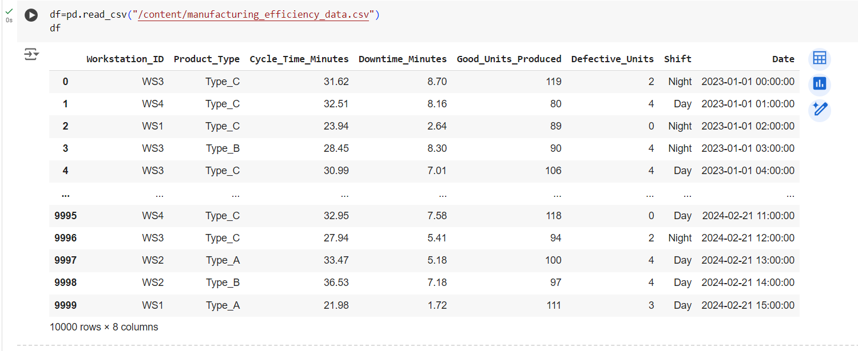

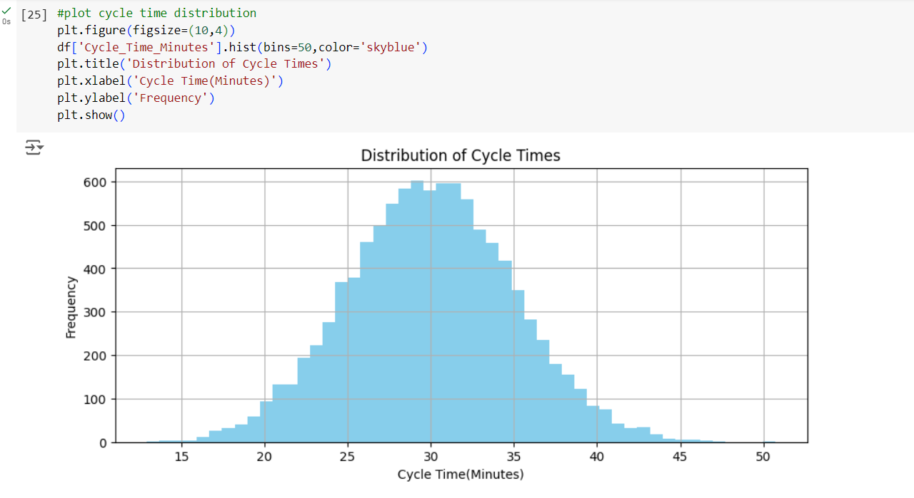

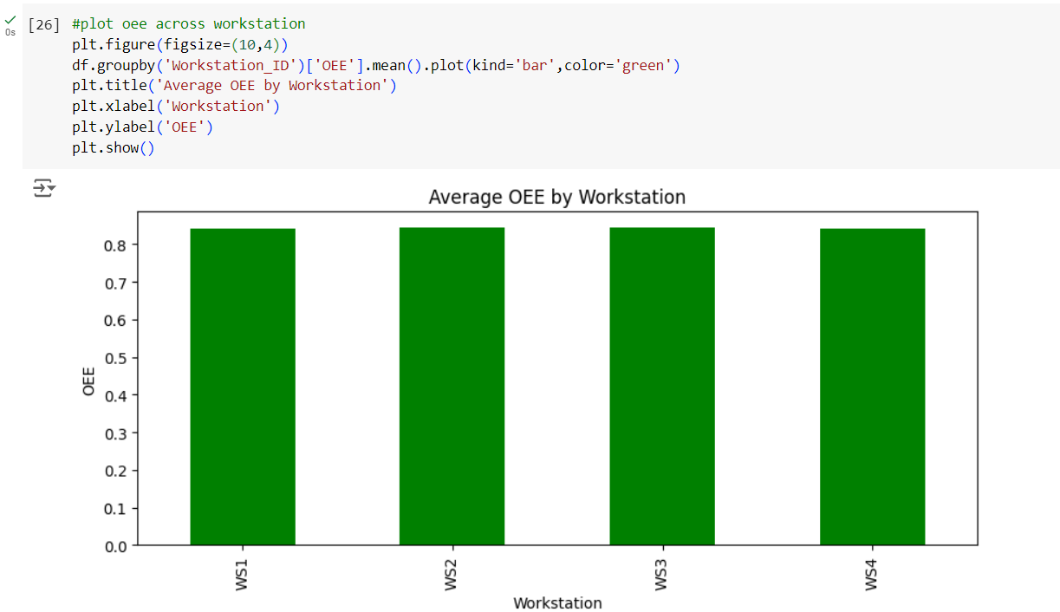

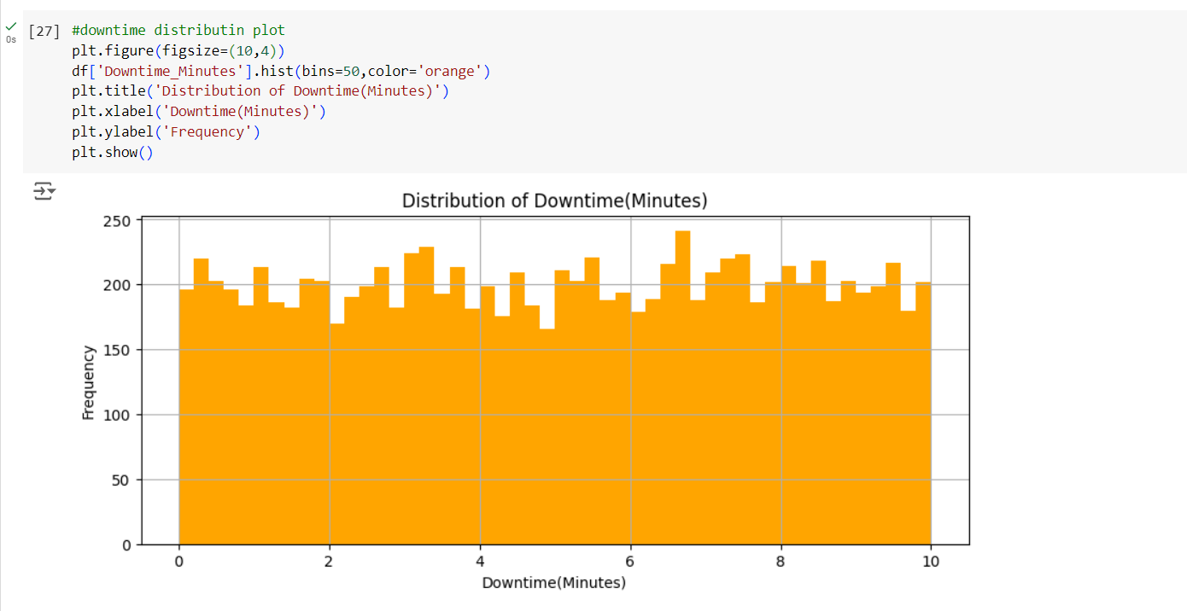

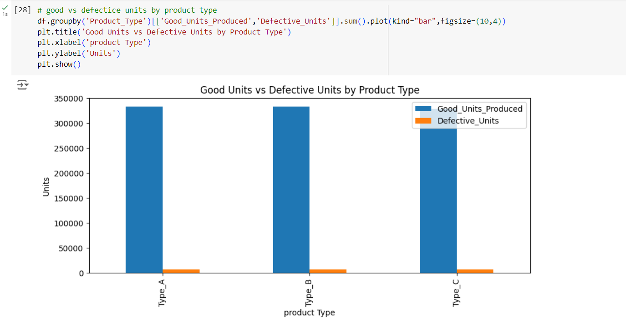

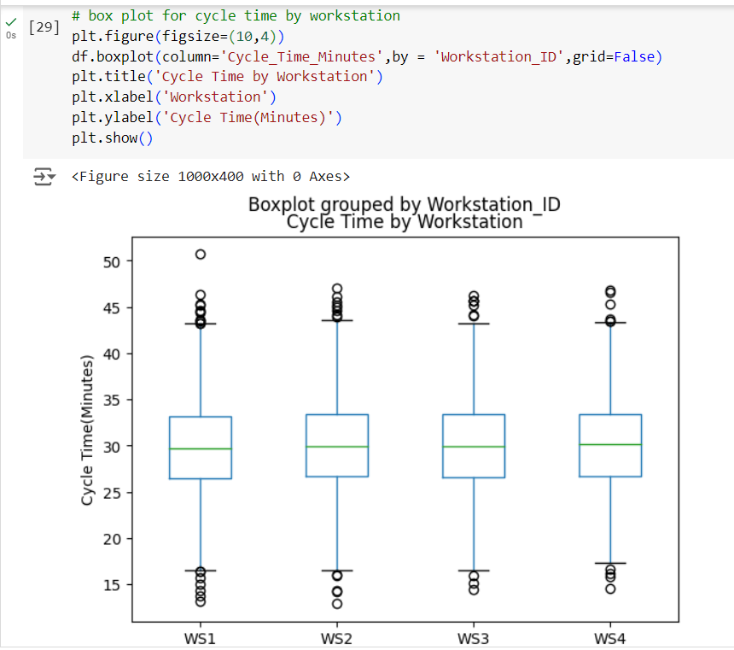

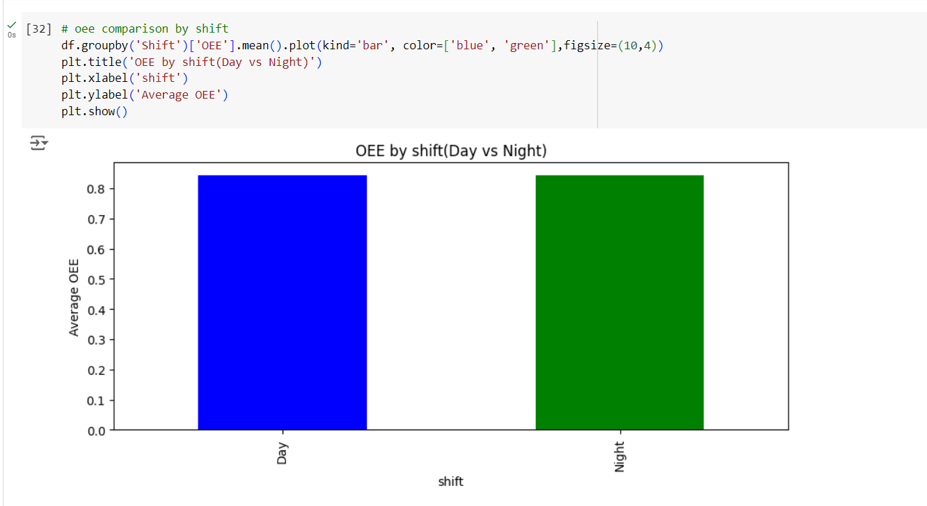

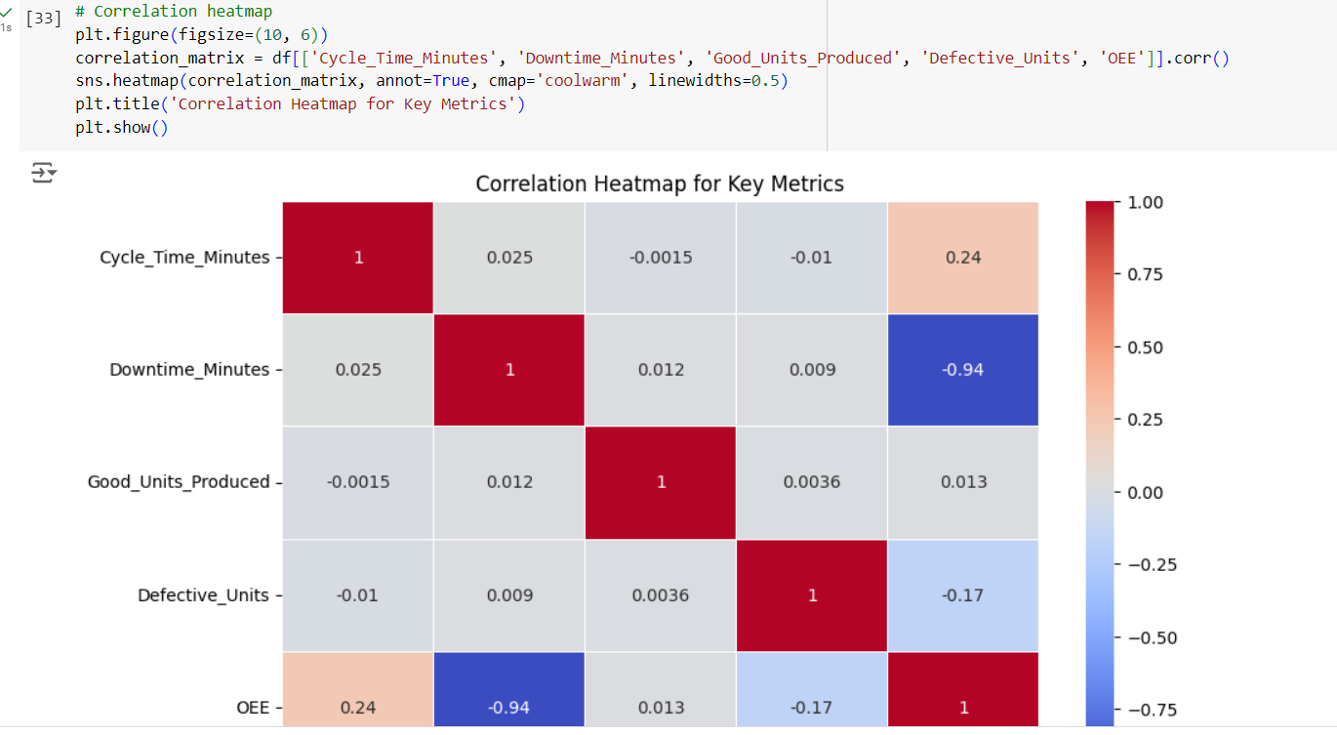

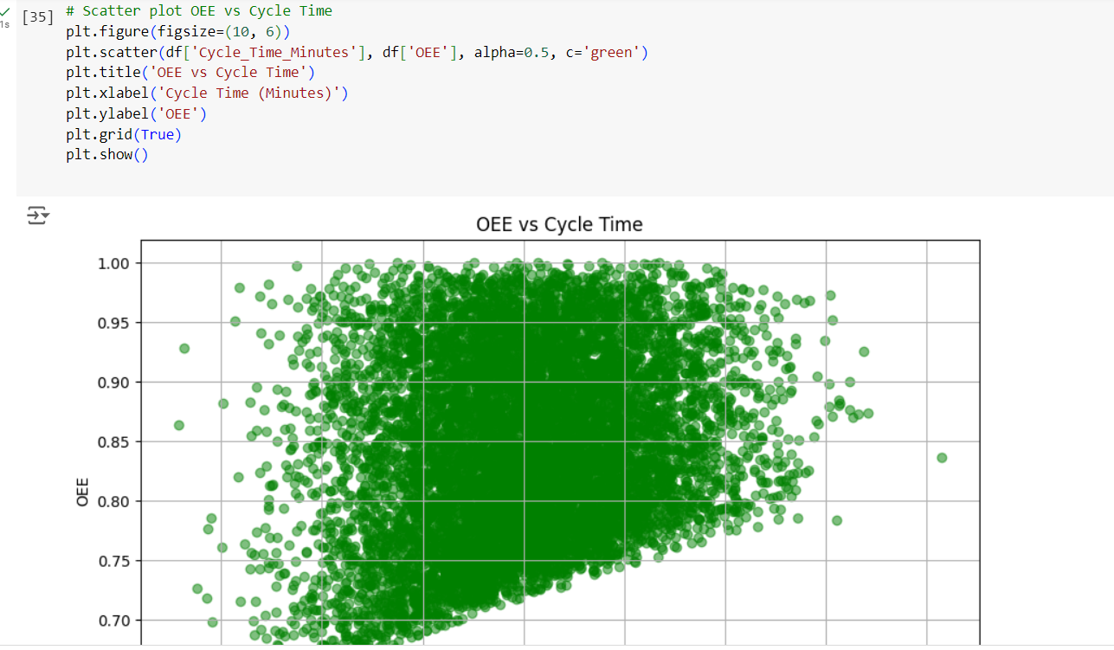

**Progress**

* **Accomplishments:**

1. Synthetic Dataset Analyzed: Successfully analyzed a comprehensive synthetic dataset simulating real-world manufacturing operations.
2. Data Quality Assessment: Conducted a thorough check for null values, ensuring data integrity and completeness.
3. OEE Calculation: Developed a method to calculate Overall Equipment Effectiveness (OEE), providing insights into equipment performance.
4. Resource Utilization Analysis: Analyzed resource utilization to identify efficiencies and areas for improvement in production processes.
5. Visual Data Exploration: Created multiple visualizations, including histograms, bar charts, box plots, and heatmaps, to uncover patterns and trends.
6. Bottleneck Identification: Identified potential bottlenecks in production through cycle time and downtime analysis.
7. Shift Performance Comparison: Compared operational performance metrics (OEE) between day and night shifts to inform staffing and scheduling decisions.
8. Correlation Insights: Analyzed correlations between key metrics, aiding in understanding relationships affecting operational efficiency.
9. Actionable Insights: Generated actionable insights from data visualizations to inform decision-making and strategic planning.
10. Comprehensive Reporting: Compiled findings and visualizations into a clear and structured report for stakeholders.

* **Metrics:**

1. **Overall Equipment Effectiveness (OEE):** Measures the effectiveness of equipment, factoring in availability, performance, and quality.
2. **Cycle Time:** The total time taken to complete one production cycle, including processing and waiting times.
3. **Downtime:** Total minutes of production loss due to equipment failure, maintenance, or other issues.
4. **Good Units Produced:** The total number of units produced that meet quality standards.
5. **Defective Units:** The total number of units produced that do not meet quality standards.
6. **Resource Utilization:** The efficiency of resource usage, calculated as the ratio of good units produced to cycle time.
7. **Production Yield:** The percentage of good units produced compared to the total units produced, indicating production efficiency.
8. **Scrap Rate:** The percentage of defective units relative to total production, highlighting waste in the manufacturing process.
9. **Throughput:** The rate at which products are produced over a specific period, indicating overall production capacity.
10. **Shift Performance Metrics:** Performance comparisons between shifts (e.g., day vs. night) to identify discrepancies and optimize staffing.

**Challenges and Solutions**

* **Challenges Faced:**

1. **Data Quality Issues:** Incomplete or inaccurate data can hinder analysis and lead to erroneous conclusions.
2. **Integration of Data Sources:** Difficulty in integrating data from multiple systems and formats can complicate the analysis process.
3. **Identifying Bottlenecks:** Pinpointing specific areas in the production process that cause delays can be challenging.
4. **Resistance to Change:** Employees may be resistant to new processes or technologies introduced based on data analysis findings.
5. **Real-time Data Monitoring:** Establishing systems for real-time data collection and monitoring can be technically complex.
6. **Limited Analytical Skills:** A lack of skilled personnel capable of performing advanced data analysis may limit effective decision-making.

* **Solutions Implemented:**

1. **Data Cleaning Procedures:** Implement robust data cleaning protocols to ensure data accuracy and completeness.
2. **Unified Data Platform:** Utilize data integration tools to consolidate data from various sources into a single platform for easier analysis.
3. **Root Cause Analysis Tools:** Employ analytical techniques and tools to effectively identify and address bottlenecks in the production process.
4. **Change Management Programs:** Develop training and change management programs to facilitate smoother transitions to new processes or technologies.
5. **Investment in IoT and Sensors:** Adopt Internet of Things (IoT) technologies and sensors for real-time data collection and monitoring.
6. **Upskilling Workforce:** Provide training and development opportunities to enhance employees' data analysis skills and promote a data-driven culture.

**Next Steps**

* **Upcoming Tasks:** Prioritize tasks based on urgency and impact, break them into manageable steps, and maintain open communication for support and clarity.
* **Goals:** Set clear, measurable objectives aligned with industry standards, and leverage data-driven insights to drive continuous improvement and operational excellence.

**Conclusion**

* **Summary:** The operational efficiency analysis in the manufacturing sector highlights the importance of data-driven decision-making to enhance productivity and reduce waste. By leveraging key metrics and addressing challenges, organizations can achieve sustainable improvements and drive overall performance.
* **Acknowledgments:** Thank you all for your time and attention; I appreciate your interest and support in our discussion today.